DESIGN DOCUMENTS

DATA FLOW DAIGRAM

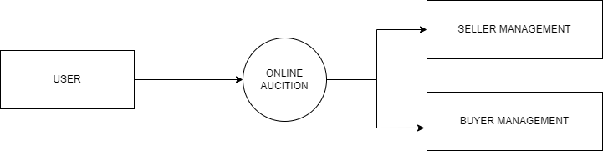

Level 0 Data flow Diagram for Online Auction

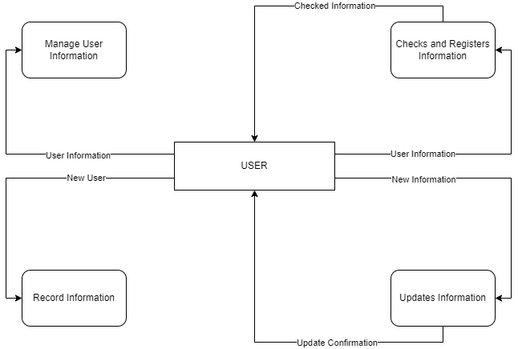

Level 1 Data flow Diagram for Online Auction

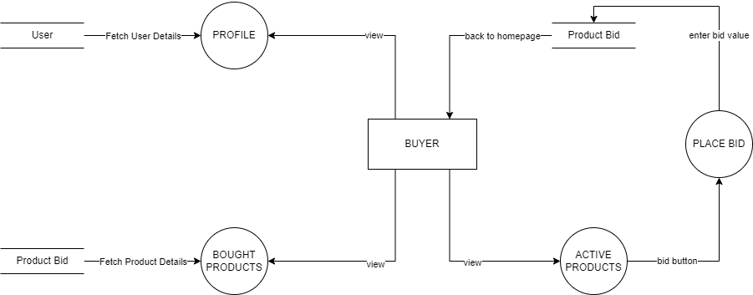

Level 2 Data flow Diagram (Buyer) for Online Auction

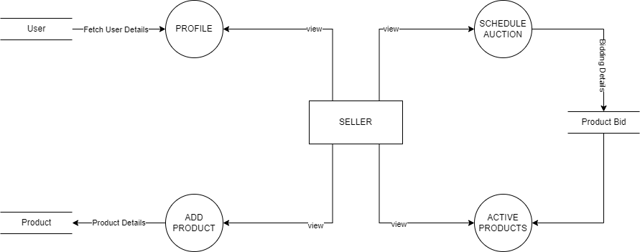

Level 2 Data flow Diagram (Seller) for Online Auction

ER DIAGRAM

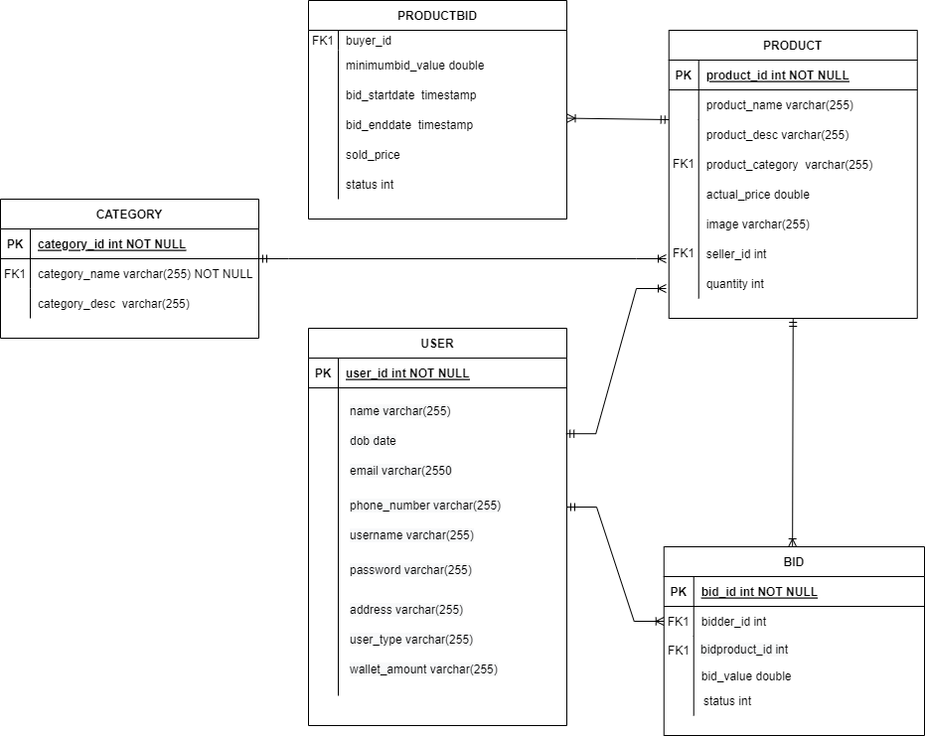

USE CASE DIAGRAM

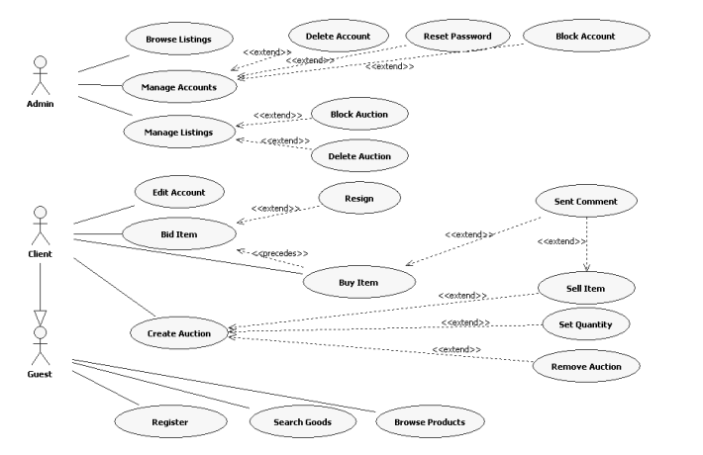

CLASS DIAGRAM

